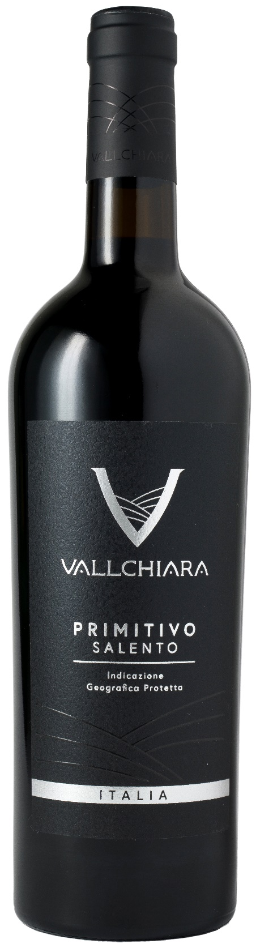
PRIMITIVO SALENTO IGP – VALLCHIARA

Grape: Primitivo 100%
Alc. Vol.%: 14
Vintage: 2024
Residual sugar g/l: 7,2
Total acidity g/l: 6,1
Region: Apulia
Production zone: Vineyards in the Salento area
Capacity: 750ml, 1500ml

CHARACTERISTICS

Vinification: After a soft pressing and the separation of grape-stalk, traditional maceration and short fermentation at a controlled temperature of 27°C.
Aging: At least 6 months in stainless-steel tanks
Yield per ha: 16000kg
Colour: Intensive red with purple reflections
Bouquet: Intensive aroma of red berries
Flavour: Full-bodied, round, pleasant and velvety

SERVING SUGGESTIONS

Excellent with grilled meat, game and poultry.
Serving temperature 16-18 °C
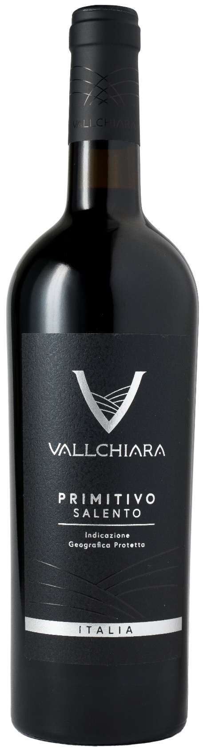
TECHNICAL INFORMATION / PALLETIZING

Size 750ml:
Article Nr. V12003A
GTIN-13 bottle 8017868001867
GTIN-13 carton 8017868004226
Closure Cork
Bottles / carton 6 bottles
Pallet size 80x120cm
Cartons/layer 21
Cartons/pallet 105
Kg/carton 8,1
Kg/pallet 870

Size 1500ml:
Article Nr. V12004A
GTIN-13 bottle 8017868003120
GTIN-13 carton 8017868002468
Closure Screwcap
Bottles / carton 6 bottles
Pallet size 80x120cm
Cartons/layer 14
Cartons/pallet 56
Kg/carton 13,4
Kg/pallet 960

Contains sulphites
GMO Free
Revisione 01. 30.05.2024

