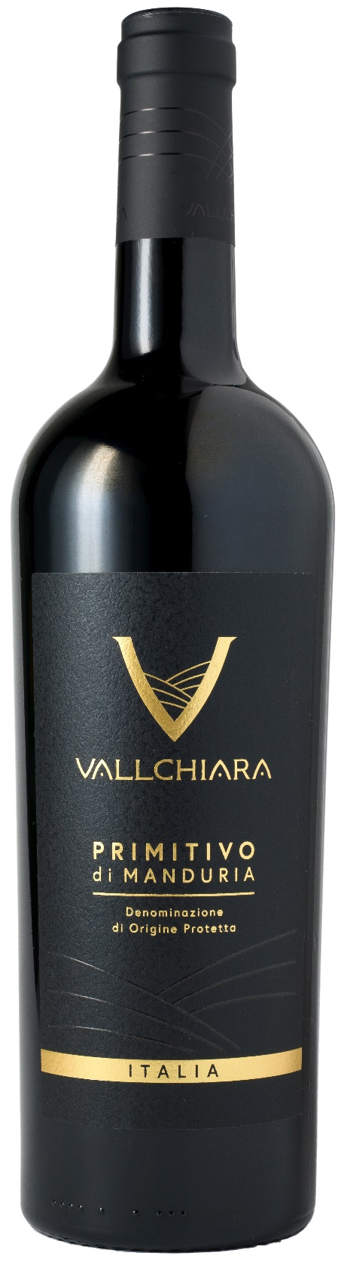
PRIMITIVO DI MANDURIA DOP – VALLCHIARA

Grape: Primitivo 100%
Alc. Vol.%: 14,5
Vintage: 2024
Residual sugar g/l: 7,2
Total acidity g/l: 6,0
Region: Apulia
Production zone: Vineyards in the area of Manduria and Sava (Taranto)
Capacity: 750ml

CHARACTERISTICS

Vinification: After a soft pressing and the separation of grape-stalk, traditional maceration and short fermentation at a controlled temperature
Aging: At least 6 months in stainless-steel tanks
Yield per ha: 9000kg
Colour: Intensive red with purple reflections
Bouquet: Fruity, intensive with notes of plum and cherry
Flavour: Full-bodied, round, pleasant and velvety

SERVING SUGGESTIONS

Excellent with various meat dishes, poultry, game and matured cheese.
Serving temperature 18 °C
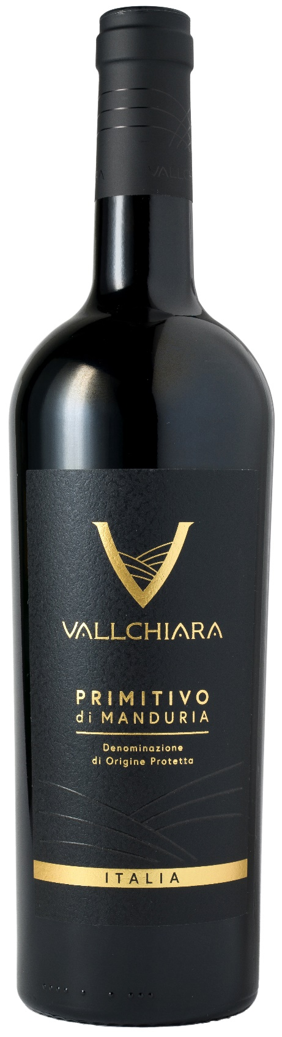
TECHNICAL INFORMATION / PALLETIZING

Size 750ml:
Article Nr. V12001A
GTIN-13 bottle 8017868003182
GTIN-13 carton 8017868003199
Closure Cork
Bottles / carton 6 bottles
Pallet size 80x120cm
Cartons/layer 21
Cartons/pallet 105
Kg/carton 8,1
Kg/pallet 870

Contains sulphites
GMO Free
Revisione 01. 14.05.2026

