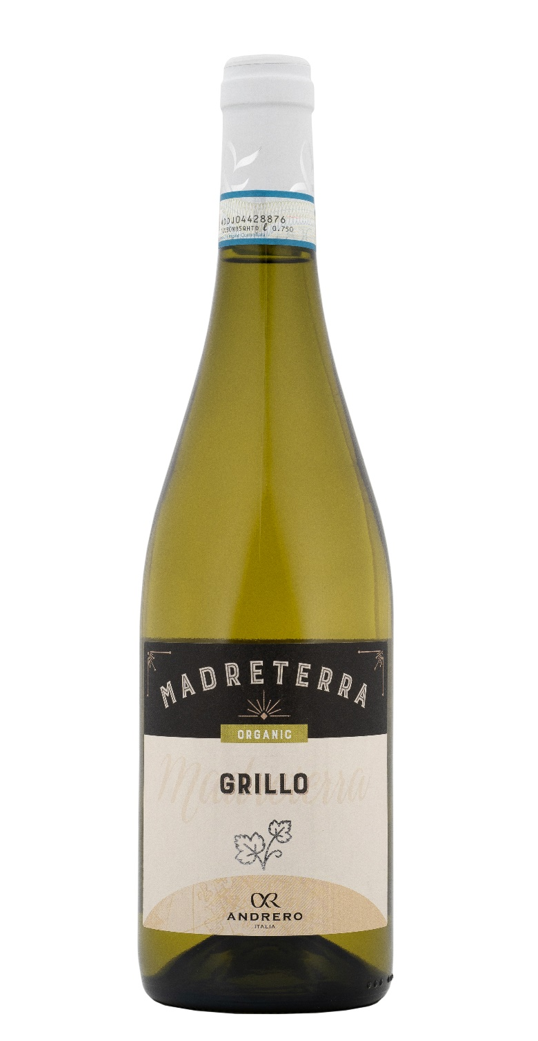
GRILLO DOP ORGANIC – MADRETERRA

Grape: Grillo 100%
Alc. Vol.%: 12,5
Vintage: 2025
Residual sugar g/l: 3,0
Total acidity g/l: 5,7
Region: Sicily
Production zone: Vineyards located in the area of Fauma / Realmonte – Province of Agrigento – Sicily
Capacity: 750ml

CHARACTERISTICS

Vinification: In steel tanks for about 12 days at a controlled temperature of 12-14°C
Yield per ha: 12000kg
Colour: Clear and shiny straw yellow
Bouquet: Fresh with notes of exotic fruit
Flavour: Dry, balanced and persistent

SERVING SUGGESTIONS

Light appetizers, fish dishes or as an aperitif.
Serving temperature 8 °C
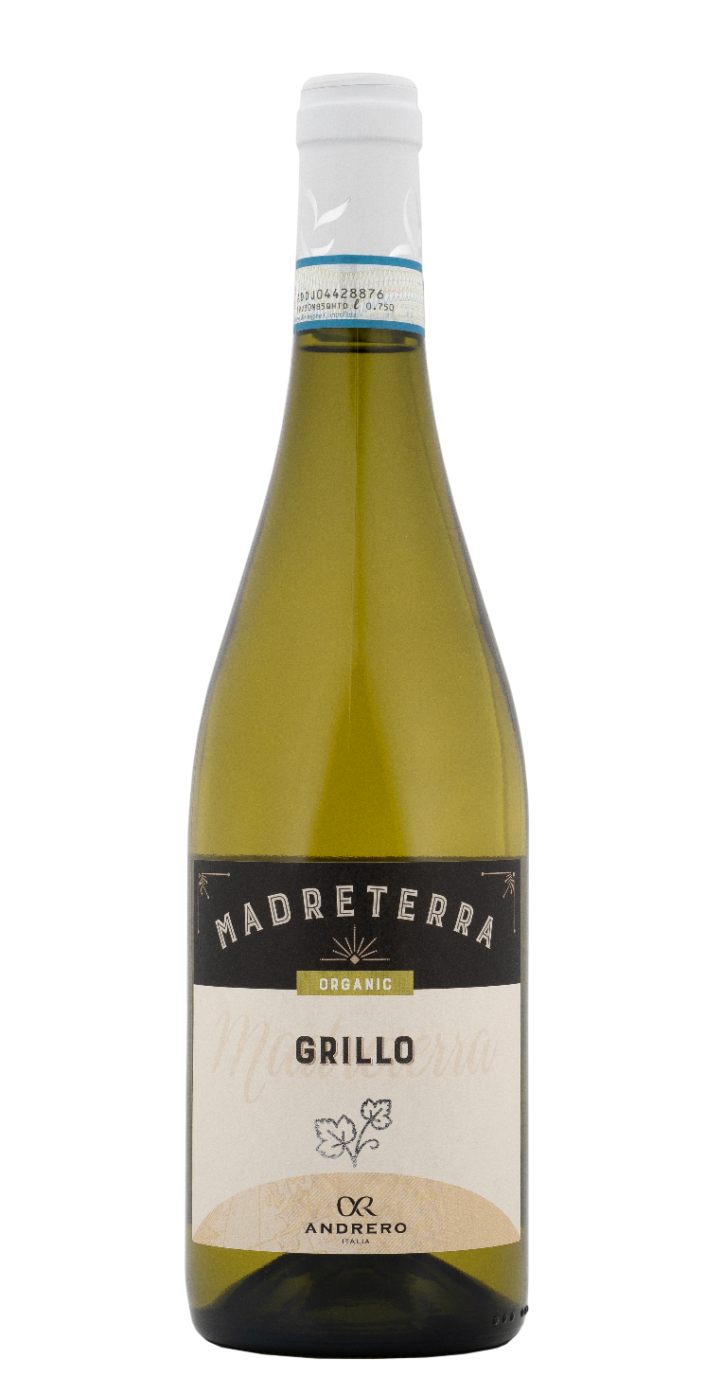
TECHNICAL INFORMATION / PALLETIZING

Size 750ml:
Article Nr. V01021A
GTIN-13 bottle 8017868001935
GTIN-13 carton 8017868002123
Closure Cork
Bottles / carton 6 bottles
Pallet size 80x120cm
Cartons/layer 21
Cartons/pallet 105
Kg/carton 7,2
Kg/pallet 775

Contains sulphites
GMO Free
Revisione 01. 21.04.2026

