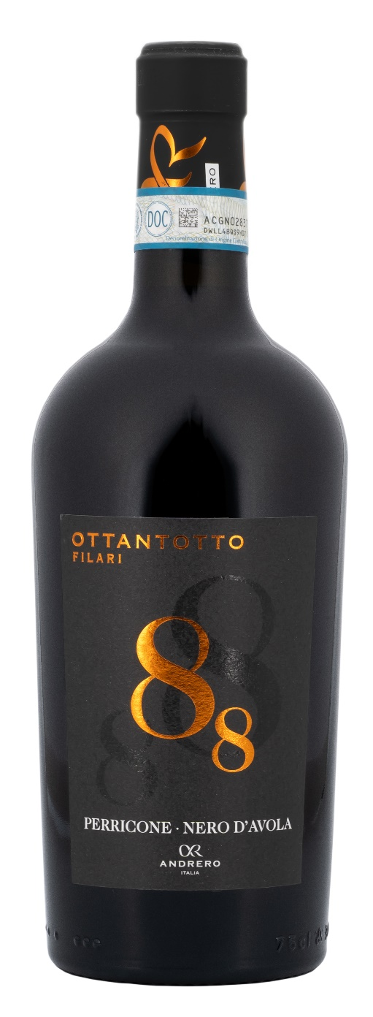
PERRICONE – NERO D’AVOLA DOP – 88 FILARI

Grape: Perricone 80%, Nero d’Avola 20%
Alc. Vol.%: 14,5
Vintage: 2023
Residual sugar g/l: 6,0
Total acidity g/l: 5,8
Region: Sicily
Production zone: Vineyards in the Province of Trapani
Capacity: 750ml

CHARACTERISTICS

Vinification: In steel tanks at a controlled temperature for 10 days of peel maceration
Aging: 12 months in steel/oak
Yield per ha: 9000kg
Colour: Intense and deep red
Bouquet: Fruity and spicy with elegant notes of vanilla
Flavour: Full-bodied, complete, absorbing taste, with elegant tannins on the finish

SERVING SUGGESTIONS

Hearty dishes, with strong flavours, or even spicy dishes, like grilled meat, roasted meat, game and mature cheeses.
Serving temperature 18 °C
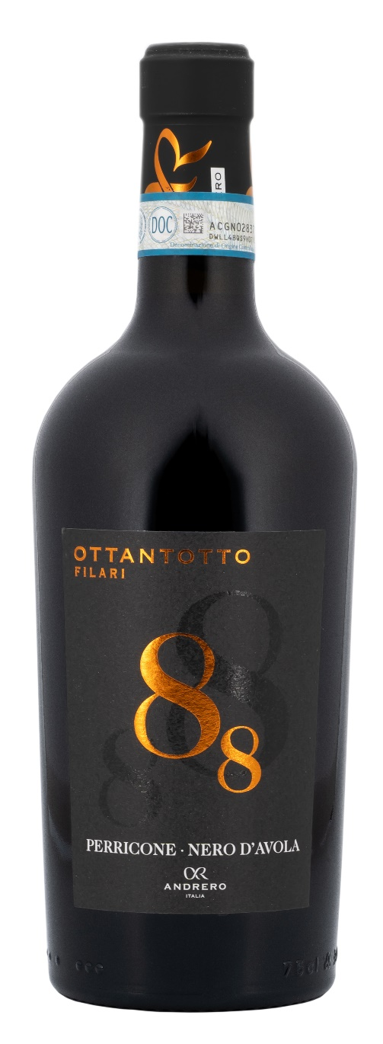
TECHNICAL INFORMATION / PALLETIZING

Size 750ml:
Article Nr. V01010A
GTIN-13 bottle 8017868001287
GTIN-13 carton 8017868001300
Closure Cork
Bottles / carton 6 bottles
Pallet size 80x120cm
Cartons/layer 17
Cartons/pallet 102
Kg/carton 8,4
Kg/pallet 884

Contains sulphites
GMO Free
Revisione 01. 21.04.2026

