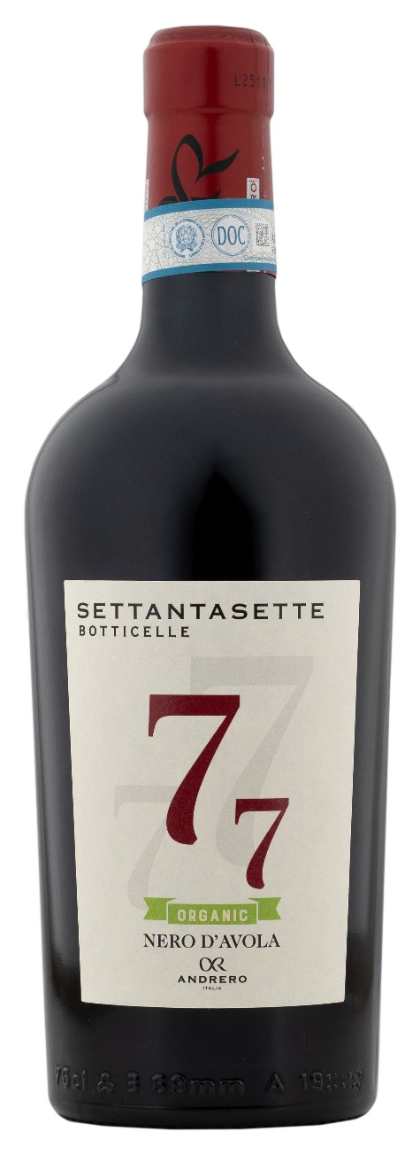
NERO D’AVOLA DOP ORGANIC – 77 BOTTICELLE

Grape: Nero d’Avola 100%
Alc. Vol.%: 14,5
Vintage: 2025
Residual sugar g/l: 5,0
Total acidity g/l: 6,2
Region: Sicily
Production zone: Vineyards in the area of Fauma / Realmonte - Province of Agrigento - Sicily
Capacity: 750ml

CHARACTERISTICS

Vinification: In steel tanks at a controlled temperature
Aging: At least 10 months in steel/oak
Yield per ha: 9000kg
Colour: Intense red color with purple reflexes
Bouquet: Intense forest fruit scents with spicy hints of vanilla and eucalyptus
Flavour: A full-bodied, deep taste but soft and fruity at the same time

SERVING SUGGESTIONS

Best enjoyed with strong flavored dishes such as grilled meat, roasted meat, game and mature cheeses.
Serving temperature 16-18 °C
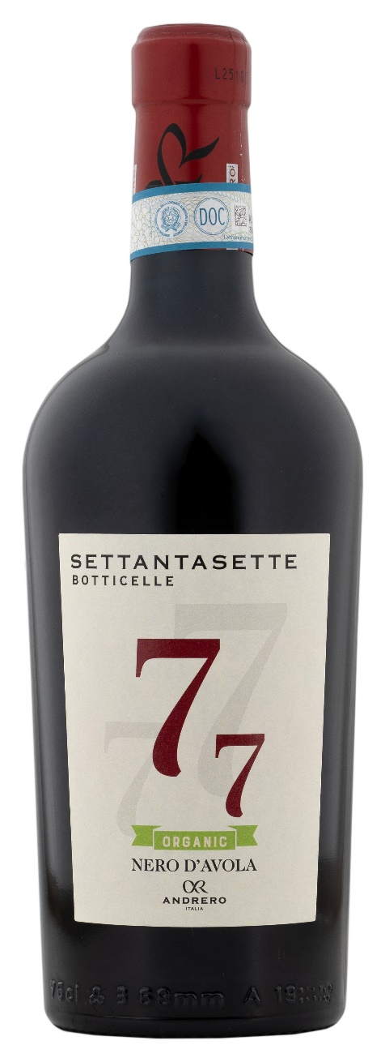
TECHNICAL INFORMATION / PALLETIZING

Size 750ml:
Article Nr. V01011A
GTIN-13 bottle 8017868000327
GTIN-13 carton 8017868000280
Closure Cork
Bottles / carton 6 bottles
Pallet size 80x120cm
Cartons/layer 17
Cartons/pallet 102
Kg/carton 8,4
Kg/pallet 884

Contains sulphites
GMO Free
Revisione 01. 21.04.2026

